

Darshan University

A Project Report on

**“Wedding Decor Service”**

Under the subject

**Software Engineering (2101CS503)**

B. Tech, Semester – V

Computer Science & Engineering Department

|  |  |
| --- | --- |
| Submitted By | |
| Student Name: Khush Bhadrecha | Enrollment No.:21010101013 |
| Academic Year  (2023-2024) | |
| Internal Guide Prof. Devangi Kotak  Darshan University | Dean-DIET Dr. Gopi Sanghani  Darshan University |

|  |  |
| --- | --- |
|  | **Computer Science & Engineering Department**  **Darshan University** |

**DECLARATION**

We hereby declare that the SRS, submitted along with the **Software Engineering (2101CS503)** for entitled “Wedding Decor Service” submitted in partial fulfillment for the Semester-5 of **Bachelor Technology (B. Tech)** in **Computer Science and Engineering (CSE)** Department to Darshan University, Rajkot, is a record of the work carried out at **Darshan University, Rajkot** under the supervision of Prof. Devangi Kotak and that no part of any of report has been directly copied from any students’ reports, without providing due reference.

Khush Bhadrecha

Student’s Signature

Date:

|  |  |
| --- | --- |
|  | **Computer Science & Engineering Department**  **Darshan University** |

**CERTIFICATE**

This is to certify that the SRS on **“Wedding Decor Service” has** been satisfactorily prepared by Khush Bhadrecha(21010101013) under my guidance in the fulfillment of the course **Software Engineering (2101CS503)** work during the academic year 2023-2024.

|  |  |
| --- | --- |
| Internal Guide  Prof. Devangi Kotak Darshan University | Dean-DIET  Dr. Gopi Sanghani Darshan University |

**ACKNOWLEDGEMENT**

I wish to express my sincere gratitude to my project guide Prof. Devangi Kotak and all the faculty members for helping me through my project by giving me the necessary suggestions and advice along with their valuable co-ordination in completing this work.

I also thank my parents, friends and all the members of the family for their precious support and encouragement which they had provided in completion of my work. In addition to that, I would also like to mention the Darshan University personals who gave me permission to use and experience the valuable resources required for the project from the University premises.

Thus, in conclusion to the above said, I once again thank the faculties and members of

**Darshan University** for their valuable support in completion of the project.

Thanking You

**Khush Bhadrecha**

**ABSTRACT**

The Wedding Decor Company Web Application is a sophisticated platform designed to revolutionize wedding decor planning. It caters to both engaged couples and wedding decor businesses, offering a diverse array of themes and decor elements. Users can effortlessly customize and visualize their ideal wedding decor while businesses benefit from streamlined inventory management and efficient order processing. Data security is a top priority, ensuring the protection of sensitive information. The platform is optimized for performance, guaranteeing a seamless user experience. This application marks a pivotal shift in the wedding decor industry, creating a digital ecosystem that seamlessly connects couples' dreams with decor professionals' expertise.

**Table of Contents**

List of Figures I

List of Tables II

1. Introduction 1
   1. Product perspective 1
   2. Product features 1
      1. There are three different users who will be using this product: 1
      2. The features that are required for the admin are: 1
      3. The features that are required for the Customer are 1
   3. Functional Requirement 1
      1. Admin 1
      2. Customer 1
   4. Non-Functional Requirement 2
      1. Usability 2
      2. Accuracy 2
      3. Availability 2
      4. Maintainability 2
2. Design and Implementation Constraints 3
   1. Use case diagram 3
   2. Activity diagram and Swimlane diagram 4
   3. Sequence diagram 5
   4. State diagram 6
   5. Class diagram 7
   6. Data flow diagram 8
      1. Context diagram (level 0) 8
      2. DFD Level-1 9
      3. DFD Level-2 10
3. External interface requirement (Screens) 11
   1. Screen-1: Add Theme Details Form 11
   2. Screen-2: Category vise Themes List 12
   3. Screen-3: Place Order Form 13
4. Database design 14
   1. List of Tables 14
5. Stories and Scenario 16
   1. Story-1: Add Themes 16
      1. Scenario# S1.1 16
      2. Scenario# S1.2 16
      3. Scenario# S1.3 17
   2. Story-2: Add Categories 17
   3. Story-3: Edit Theme Details 17
   4. Story-4: View Theme Details 17
   5. Story-5: Search Themes 18
   6. Story-5: Place Order 18
      1. Scenario# S2.1 18
      2. Scenario# S2.2 19
      3. Scenario# S2.3 19
   7. Story-7: Payment 19
   8. Story-8: Add Testimony 20
      1. Scenario# S3.1 20
      2. Scenario# S3.2 20
   9. Story-9: Order Management 21
   10. Story-10: Admin Login 21
6. Test cases 22
7. References 38

# List of Figures

Figure 2.1-1 Use case diagram for Wedding Decor Service 3

Figure 2.2-1 Activity diagram for Add Theme 4

Figure 2.2-2 Swimlane diagram for Add Theme 4

Figure 2.3-1 Sequence diagram for Add Theme 5

Figure 2.4-1 State diagram of Theme 6

Figure 2.4-2 State diagram for Payment 6

Figure 2.5-1 Class diagram for Wedding Decor Service 7

Figure 2.6-1 Context diagram for Wedding Decor Service 8

Figure 2.6-2 DFD level-1 for Wedding Decor Service 9

Figure 2.6-3 DFD level-2 for Placing Order 10

Figure 3.1-1 Screen-1: Add Theme 11

Figure 3.2-1 Screen-2: Category vise Theme List 12

Figure 3.3-1 Screen-3: Placing Order 13

# List of Tables

Table 3.1-1 Screen element of Add Theme form 11

Table 3.2-1 Screen element of Category vise Theme List 12

Table 3.3-1 Screen element of Placing Order 13

Table 4.1-1 Table: User 14

Table 4.1-2 Table: Admin 14

Table 4.1-3 Table: Theme 15

Table 4.1-4 Table: Testimony 15

Table 4.1-4 Table: Payment 15

Table 4.1-4 Table: Order 15

# Introduction

## Product perspective

The Wedding Decor Company Web Application is envisioned as a transformative digital tool that enhances wedding decor planning for both engaged couples and decor businesses. It brings a wide range of decor options to users' fingertips while simplifying inventory management and order processing for businesses. This platform aims to redefine the wedding decor industry by seamlessly connecting the creative aspirations of couples with the capabilities of decor professionals.

## Product features

### There are three different users who will be using this product:

* Admin who will be acting as the administrator.
* Customer who will be using the service.

### The features that are required for the admin are:

* Can be able to add, update or delete a category.
* Can be able to add, update or delete a theme.
* Can be able to manage orders.
* Can be able to review all testimonials given by the customers.
* Can be able to manage all payments.

### The features that are required for the Customer are:

* Can view the different categories of themes available.
* Can view the List of themes available in each category.
* Can give a testimony based on the service received by the company .
* Can place a order or even cancel the order
* Can put a request for a new book.

## Functional Requirement

### Admin

* Add Theme: New Themes must be entered in database.
* Update Theme: Any changes in themes should be updated in case of update.
* Delete Theme: Wrong entry must be removed from system.
* Add Category: New Category must be entered in database
* Delete Category: Wrong entry must be removed from system.
* Update Category: Any changes in category should be updated in case of update.
* Manage Payment: Admin should be able to manage payments, including capturing payment information. Authorizing transactions and recording payment status.
* Order Management: Admin should be able to view, create and modify and admin should able to see updated list after removing all the cancelled order(if any).
* Review Testimonial’s: Admin should be able to review testimonials submitted by customers.

### Customer

* Browse Decor option: Customers can explore a variety of wedding decor options available on the platform.
* View Decor details: Customers can access detailed information about specific wedding decor items, including images, descriptions, and pricing.
* Add Testimony: Customers have the ability to share their testimonials and feedback about the decor and services they have experienced.
* Delete Testimony: Customers can remove or retract their previously submitted testimonials if needed.
* Update Testimony: Customers can edit or modify their existing testimonials to provide more accurate or updated feedback.
* Search Themes: Customers can search, and filter wedding decor themes based on various criteria such as color, style, or price.
* Make Payment: Customers can securely make payments for their selected decor items and services through the platform.
* Placing Order: Customers can place orders for the selected decor items, specifying details such as quantity, event date, and venue.
* Cancel Order: Customers have the option to cancel their placed orders, subject to cancellation policies, if their plans change or if they no longer require the decor services.

## Non-Functional Requirement

### Usability:

* The UI should be simple enough for everyone to understand and get the relevant information without any special training. Different languages can be provided based on the requirements.

### Accuracy:

* The data stored about the books and the fines calculated should be correct, consistent, and reliable.

### Availability:

* The System should be available for the duration when the library operates and must be recovered within an hour or less if it fails. The system should respond to the requests within two seconds or less.

### Maintainability:

* The software should be easily maintained and adding new features and making changes to the software must be as simple as possible. In addition to this, the software must also be portable.

# Design and Implementation Constraints

## Use case diagram

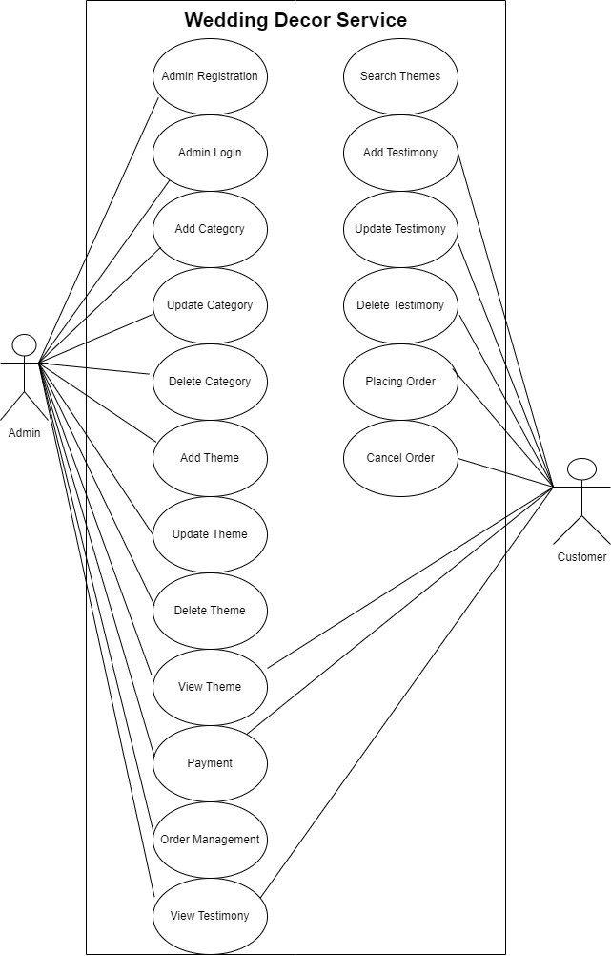

*Figure 2.1-1 Use case diagram for Wedding Decor Service*

## Activity diagram and Swimlane diagram

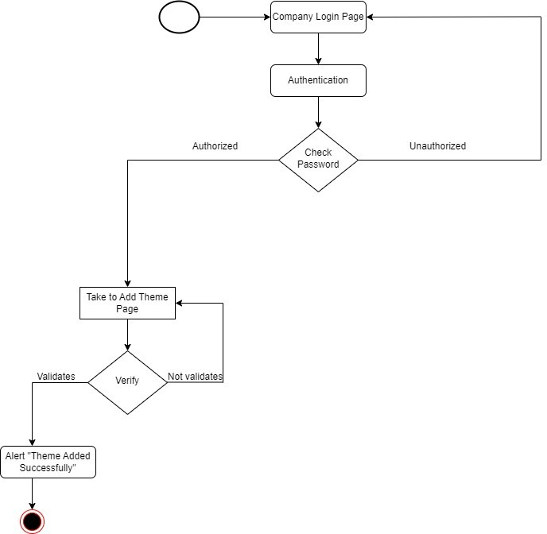

*Figure 2.2-1 Activity diagram for Adding a theme*

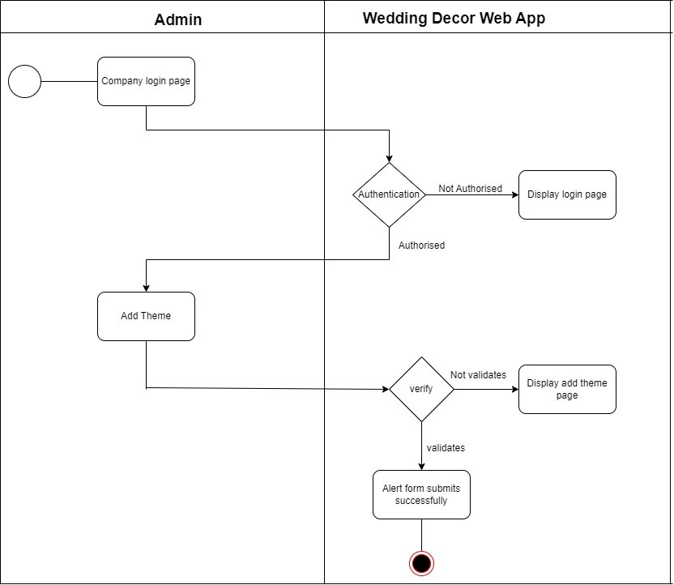

*Figure 2.2-2 Swimlane diagram for Adding a Theme*

## Sequence diagram

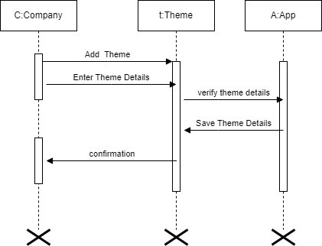

*2.3-1 Sequence diagram for Adding a Theme*

## State diagram

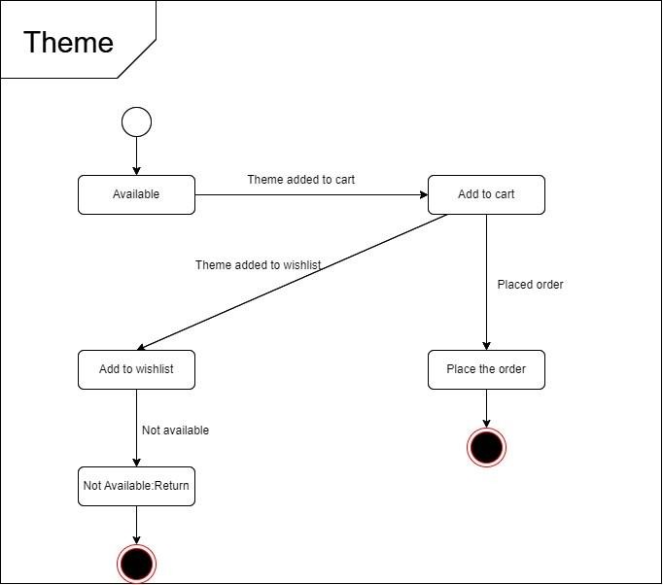

*Figure 2.4-1 State diagram of Theme*

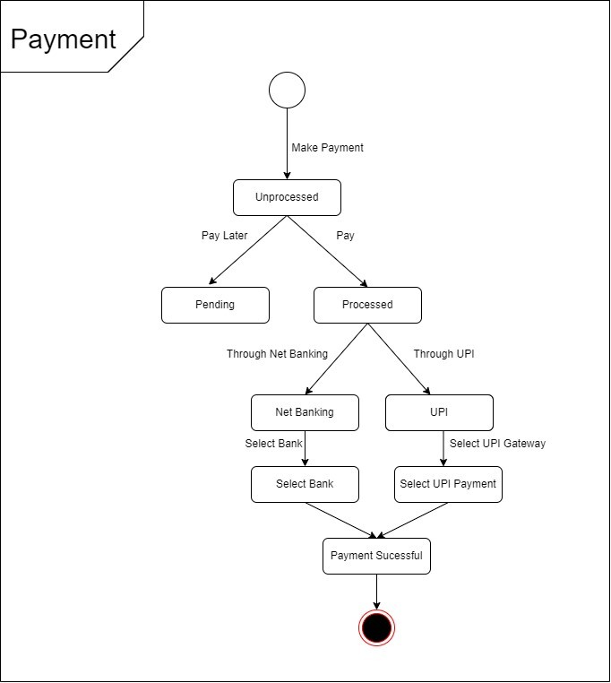

*Figure 2.4-2 State diagram for Payment*

## Class diagram

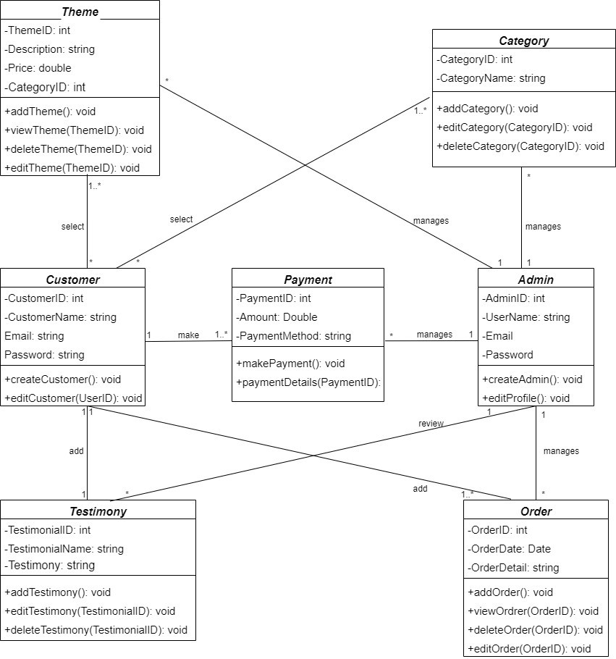

*Figure 2.5-1 Class diagram for Wedding Decor Service*

## Data flow diagram

### Context diagram (level 0)

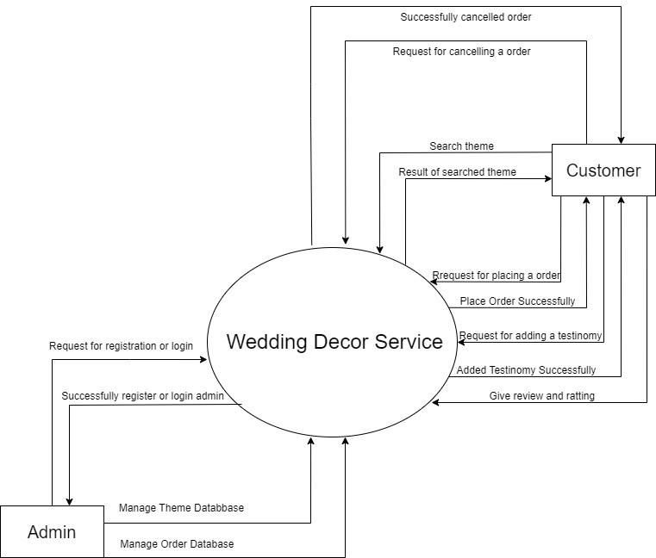

*Figure 2.6-1 Context diagram for Wedding Decor Service*

### DFD Level-1

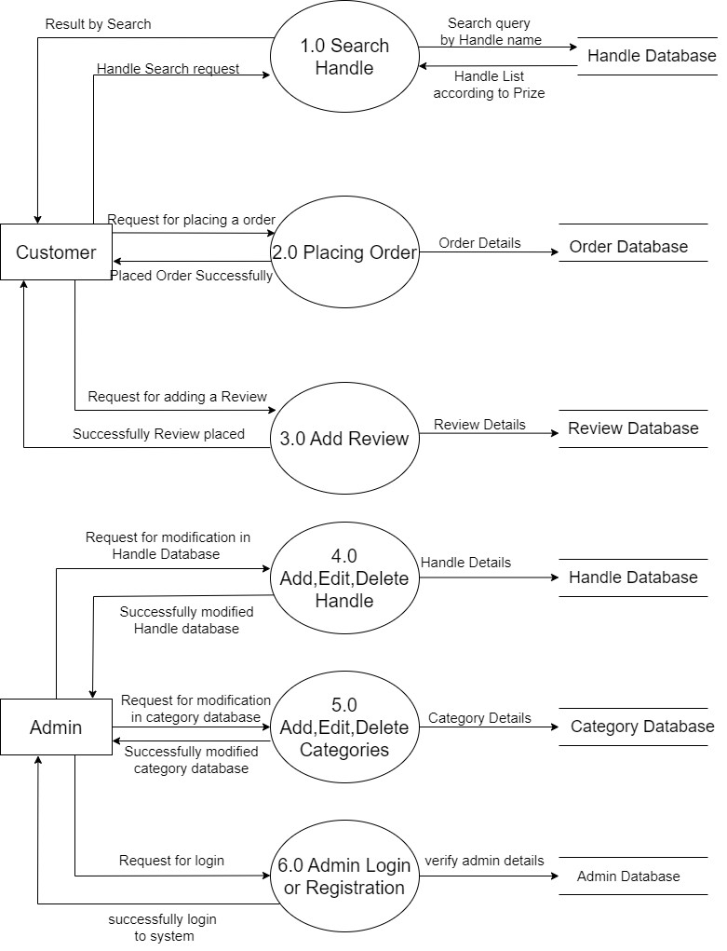

*Figure 2.6-2 DFD level-1 for Wedding Decor Service*

### DFD Level-2

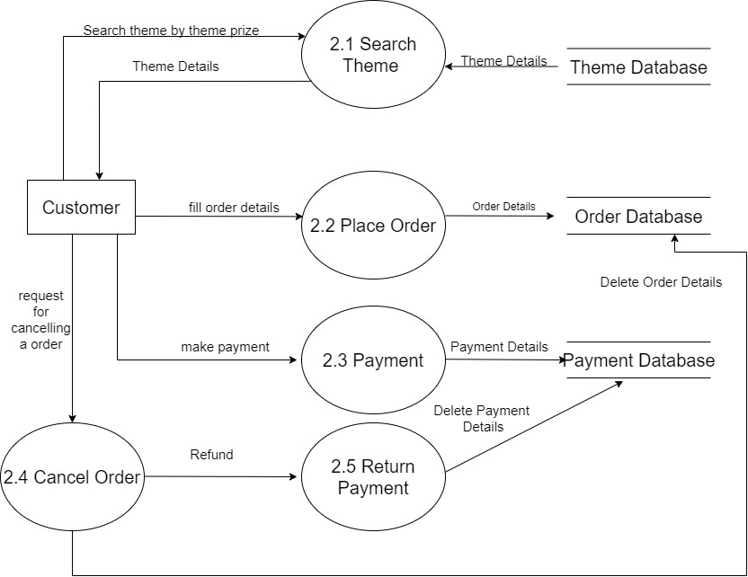

*Figure 2.6-3 DFD level-2 for placing order.*

# External interface requirement (Screens)

## Screen-1: Add Theme Details Form

*Figure 3.1-1 Screen-1: Add Theme*

**Purpose:** This form will allow the admin to add theme details in the system. To add, the following information will be encoded in the system.

*Table 3.1-1 Screen element of Add Theme*

|  |  |  |  |  |  |
| --- | --- | --- | --- | --- | --- |
| **Sr.** | **Screen Element** | **Input Type** | **O/M** | **1/N** | **Description** |
| **1** | Category Name | Dropdown | M | 1 | It will add the name of the category |
| **2** | Theme Image | Textbox | M | 1 | It will add the absolute or relative path of the  image. |
| **3** | Theme  Description | Textbox | M | 1 | It will add description about the theme. |
| **4** | Theme Price | Text | M | 1 | It will add the price of the theme. |
| **5** | Theme Color | Textbox | M | 1 | It will add the color of the theme. |
| **6** | Add Theme | Button | ------ | ------ | Add Theme is a button for store the entered data  into database. |
| **7** | Back categories | Button | ------ | ------ | Back to categories is a button which will navigate  back to categories page. |

## Screen-2: Category vise Themes List

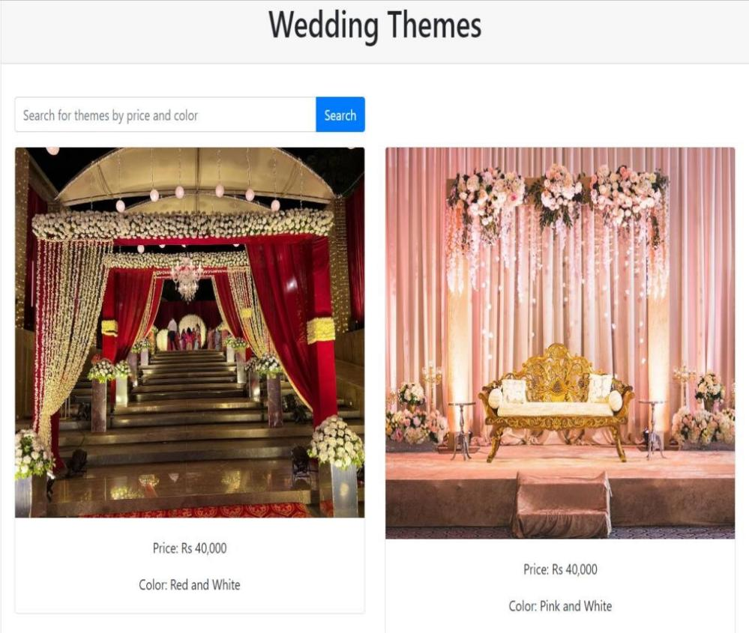

*Figure 3.2-1 Screen-2: Category vise Theme List*

**Purpose:** The category vise theme page presents users with a dedicated space to explore themes within a chosen category.Users can search for a specific theme within that category using a search bar.

*Table 3.2-1 Screen element of Place Order*

|  |  |  |  |  |  |
| --- | --- | --- | --- | --- | --- |
| **Sr.** | **Screen Element** | **Input Type** | **O/M** | **1/N** | **Description** |
| **1** | Category Name | Output | M | 1 | Displays the name of the selected category. |
| **2** | Search Bar | Input | M | 1 | Allows users to enter keywords for them to  search within the category. |
| **3** | Theme Image | Output/link | M | N | Displays the image of theme and when user click on theme it will be redirect to theme details  page. |
| **4** | Price | Output | M | N | Displays the price of the theme. |
| **5** | Color | Output | M | N | Display the name of the color which are used in  theme. |

## Screen-3: Place Order Form

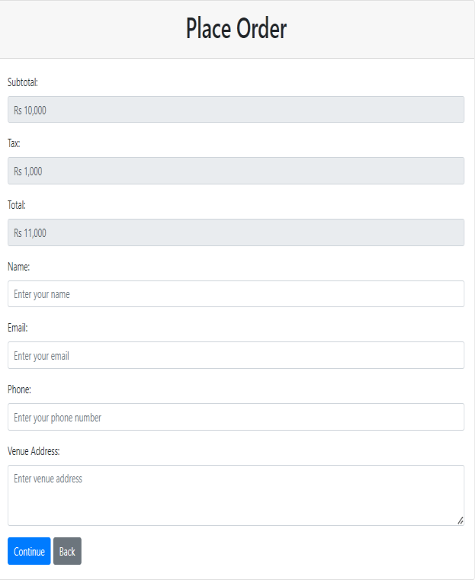

*Figure 3.3-1 Screen-3: Place*

**Purpose:** The order placement page allows users to review and finalize their order details for the chosen theme. This page guides users through the process of placing their order, presenting order details, collecting necessary information.

*Table 3.3-1 Screen element of Place Order*

|  |  |  |  |  |  |
| --- | --- | --- | --- | --- | --- |
| **Sr.** | **Screen Element** | **Input Type** | **O/M** | **1/N** | **Description** |
| **1** | Subtotal | Output | M | 1 | Displays the calculated subtotal of selected theme. |
| **2** | Tax | Output | M | 1 | Displays the applicable tax amount for the order. |
| **3** | Total | Output | M | 1 | Displays the total cost of the order including tax. |
| **4** | Name | Textbox | M | 1 | Users must fill their name in name field. |
| **5** | Email | Textbox | M | 1 | Users have to fill their email id in email field. |
| **6** | Phone Number | Textbox | M | 1 | Users have to fill their phone number in phone  number field. |
| **7** | Venue Address | Textbox | O | 1 | Users have to fill venue address in venue address  field. |
| **8** | Continue | Button | ----- | ----- | Continue is a link which will redirect user to  payment page. |
| **9** | Back | Button | ----- | ----- | Back is a button which will redirect user to theme  details page. |

# Database design

## List of Tables

* Customer
* Admin
* Category
* Theme
* Payment
* Testimonial
* Order

*Table 4.1-1 Table: Customer*

|  |  |  |  |  |
| --- | --- | --- | --- | --- |
| **Column** | **Data Type** | **Null** | **Keys & constrains** | **Default Value & Description** |
| **CustomerID** | int | NN | PK (Auto Increment) |  |
| **CustomerName** | Varchar(50) | NN |  |  |
| **ContactNO** | Varchar(10) | NN |  |  |
| **Email** | Varchar(50) | NN |  |  |
| **Password** | varchar(50) | NN |  |  |
| **Created** | DateTIme | NN |  |  |
| **Modified** | Datetime | NN |  |  |

*Table 4.1-2 Table: Admin*

|  |  |  |  |  |
| --- | --- | --- | --- | --- |
| **Column** | **Data Type** | **Null** | **Keys & constrains** | **Default Value & Description** |
| **AdminID** | int | NN | PK (Auto Increment) | - |
| **AdminName** | Varchar(50) | NN | - | - |
| **AdminPassword** | Varchar(50) | AN | - | - |
| **Created** | DateTime | AN | - | - |
| **Modified** | DateTime | AN | - | - |

*Table 4.1-3 Table: Category*

|  |  |  |  |  |
| --- | --- | --- | --- | --- |
| **Column** | **Data Type** | **Null** | **Keys & constrains** | **Default Value & Description** |
| **CategoryID** | int | NN | PK (Auto Increment) |  |
| **CategoryName** | varchar(100) | NN |  |  |
| **AdminID** | int | NN | FK |  |
| **Created** | DateTime | NN |  |  |
| **Modified** | DateTIme | NN |  |  |

*Table 4.1-4 Table: Theme*

|  |  |  |  |  |
| --- | --- | --- | --- | --- |
| **Column** | **Data Type** | **Null** | **Keys & Constrains** | **Default Value & Description** |
| **ThemeID** | int | NN | PK (Auto Increment) |  |
| **CategoryID** | varchar(100) | AN |  |  |
| **ThemeName** | varchar(100) | AN |  |  |
| **ThemeDescription** | Varchar(200) | NN |  |  |
| **Themeprize** | int | NN |  |  |
| **Themecolor** | Varchar(12) | NN |  |  |
| **Created** | Datetime | NN |  |  |
| **Modified** | Datetime | NN |  |  |
| **AdminID** | Int | FK |  |  |

*Table 4.1-5 Table: Order*

|  |  |  |  |  |
| --- | --- | --- | --- | --- |
| **Column** | **Data Type** | **Null** | **Keys & Constrains** | **Default Value & Description** |
| **OrderID** | int | NN | PK (Auto Increment) |  |
| **OrderName** | Varchar(50) | AN |  |  |
| **OrderDate** | Datetime | AN |  |  |
| **OrderDescription** | Varchar(50) | NN |  |  |
| **Created** | Datetime | NN |  |  |
| **Modified** | Datetime | NN |  |  |
| **UserID** | Int | NN | FK |  |

*Table 4.1-5 Table: Testimonial*

|  |  |  |  |  |
| --- | --- | --- | --- | --- |
| **Column** | **Data Type** | **Null** | **Keys & Constrains** | **Default Value & Description** |
| **TestimonialId** | Int | NN | PK (Auto Increment) |  |
| **TestimonialName** | Varchar(10) | AN |  |  |
| **Testimony** | Varchar(50) | AN |  |  |
| **Created** | datetime | NN |  |  |
| **Modified** | Datetime | NN |  |  |
| **UserID** | Int | NN | FK |  |

*Table 4.1-5 Table: Payment*

|  |  |  |  |  |
| --- | --- | --- | --- | --- |
| **Column** | **Data Type** | **Null** | **Keys & Constrains** | **Default Value & Description** |
| **PaymentID** | Int | NN | PK (Auto Increment) |  |
| **Amount** | Float | AN |  |  |
| **PaymentMethod** | Varchar(20) | AN |  |  |
| **transactionId** | Int | NN |  |  |
| **UserID** | Int | NN | FK |  |

# Stories and Scenario

## Story-1: Add Themes

|  |  |  |
| --- | --- | --- |
| *Story #* ***S1*** | **:** | **As a** Admin,  **I want to** add a theme.  **So that** I can expand the selection of themes available to users. |
| **Priority** | **:** | High |
| **Estimate** | **:** | XL |
| **Reason** | **:** | Adding a theme is a core functionality of the application, and it's relatively  straightforward in terms of effort, time, and complexity. |

### Scenario# S1.1

|  |  |  |
| --- | --- | --- |
| *Scenario#* ***S1.1*** | **:** | Admin enter correct details while Adding a new theme. |
| **Prerequisite** | **:** | Admin is logged in. |
| **Acceptance Criteria** | **:** | **Given:** the admin is on the "Add Theme" page.  **When:**  the admin fills in the required theme details such as name, description, price, and uploads an image.  **Then**  **Process the Testimonial:**   * Store the theme details in the system.   **Redirect to Theme List Page:**   * Take the admin to the Theme List page.   **Display Success Message:**   * Show a success message indicating that the theme was placed successfully. |

### Scenario# S1.2

|  |  |  |
| --- | --- | --- |
| *Scenario#* ***S1.2*** | **:** | Display Error on Missing Information When Adding a Theme. |
| **Prerequisite** | **:** | Admin should be logged in. |
| **Acceptance Criteria** | **:** | **Given:** the admin is on the "Add Theme" page,  **When:** the admin attempts to add a theme but leaves any of the required fields such as name, description, or price empty.  **Then**  **Prevent Theme Addition:**   * Not add the theme to the database.   **Display Error Message:**   * Show an error message indicating the missing information. |

### Scenario# S1.3

|  |  |  |
| --- | --- | --- |
| *Scenario#* ***S1.3*** | **:** | Display Error on Invalid Image Format When Adding a Theme. |
| **Prerequisite** | **:** | Admin should be logged in. |
| **Acceptance Criteria** | **:** | **Given**: the admin is on the "Add Theme" page.  **When**: the admin attempts to add a theme and selects an image file that is not in a supported format(e.g. PDF).  **Then**:  **Prevent Theme Addition:**   * Not add the theme to the database.   **Display Error Message:**   * Show an error message indicating the invalid image format. |

## Story-2: Add Categories

|  |  |  |
| --- | --- | --- |
| *Story #* ***S2*** | : | **As a** Admin,  **I want to** add a category  **So that** I can categorize different themes effectively**.** |
| **Priority** | **:** | High |
| **Estimate** | **:** | L |
| **Reason** | **:** | Adding a category is a fundamental part of organizing themes, but it's  relatively straightforward. |

## Story-3: Edit Theme Details

|  |  |  |
| --- | --- | --- |
| *Story #* ***S3*** | **:** | **As a** admin,  **I want** to edit a theme.  **So that** I can update theme details when necessary. |
| **Priority** | **:** | Medium |
| **Estimate** | **:** | L |
| **Reason** | **:** | Editing a theme is an essential functionality, and it involves moderate effort and complexity as it requires updating existing data without compromising the  integrity of the application. |

## Story-4: View Theme Details

|  |  |  |
| --- | --- | --- |
| *Story #* ***S3*** | **:** | **As a** customer,  **I want** to view theme details.**.**  **So that** I can see all the information related to a specific theme. |
| **Priority** | **:** | High |
| **Estimate** | **:** | S |
| **Reason** | **:** | Viewing theme details is a fundamental part of theme management and  involves a relatively small effort and complexity. |

## Story-5: Search Themes

|  |  |  |
| --- | --- | --- |
| *Story #* ***S3*** | **:** | **As a** customer,  **I want** to search for themes  **So that** I can quickly find specific themes based on criteria. |
| **Priority** | **:** | Low |
| **Estimate** | **:** | L |
| **Reason** | **:** | Searching for themes is an important feature for theme management, and it  involves a moderate effort due to implementing search functionality. |

## Story-5: Place Order

|  |  |  |
| --- | --- | --- |
| *Story #* ***S3*** | **:** | **As a** customer  **I want** to place an order for a theme.  **So that** I can book the selected theme for my event. |
| **Priority** | **:** | High |
| **Estimate** | **:** | XXL |
| **Reason** | **:** | Placing an order involves complex calculations of the total amount based on room  type, room count, night count, and guest count, which makes it a high-effort and complex task. |

### Scenario# S2.1

|  |  |  |
| --- | --- | --- |
| *Scenario#* ***S1.1*** | **:** | Placing an order successfully. |
| **Prerequisite** | **:** | Web page of placing order should be displayed correctly. |
| **Acceptance Criteria** | **:** | **Given:** the customer is on the order page.  **When:**  the customer enters valid information including the total amount, Name, Contact Details, Email, date of the event, and venue address.  **Then**  **Process the Order:**   * Create an order with the provided details. * Calculate the total order amount accurately. * Store the order in the system.   **Redirect to Payment Page:**   * Take the customer to the payment page to complete the order.   **Display Success Message:**   * Show a success message indicating that the order was placed successfully. |

### Scenario# S2.2

|  |  |  |
| --- | --- | --- |
| *Scenario#* ***S1.1*** | **:** | Failing to Place Order Due to Missing Information |
| **Prerequisite** | **:** | Web page of placing order should be displayed correctly. |
| **Acceptance Criteria** | **:** | **Given:** the customer is on the order page.  **When:**  the customer attempts to place an order but leaves any of the required fields such as Name, Contact Details, Email, date of the event, or venue address empty.  **Then**  **Prevent Order Placement:**   * Not allow the customer to place the order.   **Redirect to Payment Page:**   * Take the customer to the payment page to complete the order.   **Display Error Message:**   * Show an error message indicating the missing information. |

### Scenario# S2.3

|  |  |  |
| --- | --- | --- |
| *Scenario#* ***S1.1*** | **:** | Failing to Place Order Due to Invalid Email Address. |
| **Prerequisite** | **:** | Web page of placing order should be displayed correctly. |
| **Acceptance Criteria** | **:** | **Given:** the customer is on the order page.  **When:**  the customer attempts to place an order with an invalid email address format (e.g., missing '@' symbol).  **Then**  **Prevent Order Placement:**   * Not allow the customer to place the order.   **Redirect to Payment Page:**   * Take the customer to the payment page to complete the order.   **Display Error Message:**   * Show an error message indicating the invalid email format. |

## Story-7: Payment

|  |  |  |
| --- | --- | --- |
| *Story #* ***S3*** | **:** | **As a** customer  **I want** to make a payment for my order.  **So that** I can confirm my reservation and pay for the selected theme. |
| **Priority** | **:** | High |
| **Estimate** | **:** | M |
| **Reason** | **:** | Making a payment is a critical step in the booking process but is relatively  straightforward as it involves standard payment gateway integration. |

## Story-8: Add Testimony

|  |  |  |
| --- | --- | --- |
| *Story #* ***S3*** | **:** | **As a** customer  **I want** to add a testimony.  **So that** I can share my experience with others using the service. |
| **Priority** | **:** | Low |
| **Estimate** | **:** | XS |
| **Reason** | **:** | Submitting a testimony is a valuable feature for user engagement and involves a relatively small effort and complexity. |

### Scenario# S3.1

|  |  |  |
| --- | --- | --- |
| *Scenario#* ***S1.1*** | **:** | Adding a Testimonial successfully |
| **Prerequisite** | **:** | Web page of adding testimony should be displayed correctly. |
| **Acceptance Criteria** | **:** | **Given:** the customer is on the add testimony page.  **When:**  the customer enters a valid testimonial name and their testimonial text.  **Then**  **Process the Testimonial:**   * Store a testimonial in the system. * Calculate the total order amount accurately. * Store the order in the system.   **Redirect to Testimonials Page:**   * Take the customer to the testimonials page.   **Display Success Message:**   * Show a success message indicating that the testimony was placed successfully. |

### Scenario# S3.2

|  |  |  |
| --- | --- | --- |
| *Scenario#* ***S1.1*** | **:** | Failing to add testimonial Due to Missing Information |
| **Prerequisite** | **:** | Web page of adding testimony should be displayed correctly. |
| **Acceptance Criteria** | **:** | **Given:** the customer is on the add testimony page.  **When:**  the customer attempts to add a testimonial but leaves any of the required fields such as testimonial name or text empty,  **Then**  **Prevent Testimonial Addition:**   * Not allow the customer to place the order.   **Redirect to Payment Page:**   * Take the customer to the add the testimonial.   **Display Error Message:**   * Show an error message indicating the missing information. |

## Story-9: Order Management

|  |  |  |
| --- | --- | --- |
| *Story #* ***S3*** | **:** | **As a** admin  **I want** to manage customer orders.  **So that** I can process and track order efficiently. |
| **Priority** | **:** | Medium |
| **Estimate** | **:** | M |
| **Reason** | **:** | Order management is a critical admin functionality but is relatively  straightforward, involving tasks like order processing and tracking. |

## Story-10: Admin Login

|  |  |  |
| --- | --- | --- |
| *Story #* ***S3*** | **:** | **As a** admin  **I want** to log in to login panel.  **So that** I can access and manage the application administrative functions. |
| **Priority** | **:** | High |
| **Estimate** | **:** | XS |
| **Reason** | **:** | Admin login is a vital part of the application's security and functionality and is  relatively straightforward. |

# Test cases

|  |  |  |  |
| --- | --- | --- | --- |
| **Project Name:** | **Wedding Decor** | **Test Designed by:** | **Khush Bhadrecha** |
| **Module Name:** | **Order** | **Test Designed date:** | 25-08-2023 |
| **Release Version:** | **1.0** | **Test Executed by:** | **Khush Bhadrecha** |
|  |  | **Test Execution date:** | 25-08-2023 |

|  |  |  |  |  |
| --- | --- | --- | --- | --- |
| **Precondition**: **Web application should be accessible** | | | | |
| **Test Case ID** | **Test Title** | **Test Type** | **Description** | **Test Case ID** |
| **TC_01_1** | Placing Order  Successfully with valid details. | Functional | Order is successfully displayed | TC_01_1 |
| **TC_01_2** | Failing to place order  due to invalid details. | Functional | Error message displayed | TC_01_2 |
| **TC_01_3** | Verify order page  elements | GUI | verify that all elements are available  on order page | TC_01_3 |

|  |  |
| --- | --- |
| Test Case Title | Placing order successfully with valid details |
| Test Type | Functional |
| Test Priority | High |
| Precondition | Web application should be accessible |

|  |  |  |  |  |  |  |  |
| --- | --- | --- | --- | --- | --- | --- | --- |
| Test  Step | Test Case  Description | Expected Result | Actual Result | Status | Comment | Data | BUG ID |
| 1 | Access Web application URL | Access Order Page | The order  page is  displayed  successfully. | Pass |  | [HTTP://account](http://account/) s.google.com/S erviceOrder |  |
| 2 | Verify Total Amount field | Correct total amount should be fetched from the database and total amount field should not be  editable. | Correct total Amount is fetched and displayed in the total amount field. | Pass |  | Total Amount: 50000 |  |
| 3 | Enter name in name field | Name field  should be  editable and should accept name in name field. | Address field input is  accepted. | pass |  | Name: Khush Bhadrecha |  |

|  |  |  |  |  |  |  |  |
| --- | --- | --- | --- | --- | --- | --- | --- |
| 4 | Enter Mobile number in Mobile Number field | Mobile number field should be  editable and should accept mobile number in mobile number field and the  maximum length of mobile number should  be of 10 digit. | Mobile number field input accepted with the length of 10 digit. | Pass |  | Mobile NO.: 90XXXXX006 |  |
| 5 | Enter Email Address in Email address field | Email address field should be editable and should accept valid email address in email address  field. | Valid Email address in email address field is  accepted. | pass |  | Email: [xyz@gmail.co](mailto:xyz@gmail.co) m |  |
| 6 | Enter venue address in venue address field | Venue address field should be editable and should accept the venue  details. | Address field input is  accepted. | pass | Venue Address: Balaji hall |
| 7 | Enter Date of event in Date of event field | Date of Event field should be editable and should accept mobile number in mobile  number field. | Date of event field input accepted. | pass | Date: 25/8/2023 |
| 8 | Click on continue button | User should navigate to payment page. | User is  navigated to payment page | pass |  |
| 9 | Click on back button | User should navigate to  theme detail page. | User is  navigated to theme detail page. | pass |  |

|  |  |
| --- | --- |
| Test Case Title | Failing to place order due to invalid details. |
| Test Type | Functional |
| Test Priority | Medium |
| Precondition | Web application should be accessible |

|  |  |  |  |  |  |  |  |
| --- | --- | --- | --- | --- | --- | --- | --- |
| Test Step | Test Case Description | Expected Result | Actual Result | Status | Comment | Data | Bug ID |
| 1 | Verify that User is not  able to place order if total amount value is not fetched or incorrect value is fetched  from the database. | Should display an error message Something went wrong while fetching the information. | Display an error of amount value is not fetched or incorrect value is fetched. | Pass |  |  |  |
| 2 | Verify that User is not  able to navigate to payment page if User has leaved a name  field blanked. | Set required field validation for name field | Performs a validation function | Pass |  |  |  |

|  |  |  |  |  |  |  |  |
| --- | --- | --- | --- | --- | --- | --- | --- |
| 3 | Verify that User is not  able to navigate to payment page if User has leaved a mobile number field blanked or if  mobile number length is not of 10  digit. | Set required field and maximum length validation for mobile number field. | Performs a validation function | Pass |  |  |  |
| 4 | Verify that User is not  able to navigate to payment page if User has leaved a email address field blanked or if email address is not in valid  format. | Set required field and email format validation for email address field. | Performs a validation function. | Pass |  |  |  |

|  |  |  |  |  |  |  |  |
| --- | --- | --- | --- | --- | --- | --- | --- |
| 5 | Verify that User is not  able to navigate to payment page if User has leaved a venue address field  blanked. | Set required field validation for venue address field. | Performs a validation function. | Pass |  |  |  |
| 6 | Verify that User is not  able to navigate to payment page if User has leaved a  Date of event  field blanked. | Set required field validation for date field | Performs a validation function | Pass |

|  |  |
| --- | --- |
| Test Case Title | Verify order page elements |
| Test Type | GUI |
| Test Priority | Medium |
| Precondition | Web application should be accessible |

|  |  |  |  |  |  |  |  |
| --- | --- | --- | --- | --- | --- | --- | --- |
| Test Step | Test Case Description | Expected Result | Actual Result | Status | Comment | Data | Bug ID |
| 1 | Launch application with the  given URL. | The site launched properly. | Site launched successfully | Pass |  | [https://accounts.googl](https://accounts.google.com/ServiceLogin) [e.com/ServiceLogin](https://accounts.google.com/ServiceLogin) |  |

|  |  |  |  |  |  |  |  |
| --- | --- | --- | --- | --- | --- | --- | --- |
| 2 | Verify that the add order screen contains elements such as Total Amount, Name, Contact Number, Email Address,V enue Details,Eve nt Date,Paym ent Page  link. and Theme detail page link. | All listed control displayed properly on the page. | Add theme detail page loaded successfully | Pass |  |  |  |
| 3 | Verify that cursor is focused on “Name” text box on the page  load. | Cursor is focused in Name textbox. | Cursor focus in Name textbox | Pass |  |  |  |
| 4 | Verify that tab functionali ty is  working  properly or not | When tab pressed cursor move in next control. | Cursor moving in next control | Pass |  |  |  |

|  |  |  |  |  |  |  |  |
| --- | --- | --- | --- | --- | --- | --- | --- |
| 5 | Verify that all the fields such as Total Amount, Name, Contact Number, Email Address,V enue Details,Eve nt. Date has a valid  placeholde r. | All text fields have proper placehold er. | All text fields have proper placeholder | Pass |  |  |  |
| 6 | Verify that the labels float upward when the text field is in focus or filled (In  case of  floating label). | When field is focused or filled, label display on top of the filled. | When field is focus or filled, label display on top of the filled | Pass | step required when fields with floating label |  |  |
| 7 | Verify that Payment link page link working properly. | when click on Continue button load Payment  page. | Payment link page working | Pass |  |  |  |
| 8 | Verify that Theme Detail page working properly. | when click on back button load theme detail  page. | Theme detail page link working |

|  |  |  |  |
| --- | --- | --- | --- |
| **Project Name:** | **Wedding Decor** | **Test Designed by:** | **Khush Bhadrecha** |
| **Module Name:** | **Theme** | **Test Designed date:** | 25-08-2023 |
| **Release Version:** | **1.0** | **Test Executed by:** | **Khush Bhadrecha** |
|  |  | **Test Execution date:** | 25-08-2023 |

|  |  |  |  |  |
| --- | --- | --- | --- | --- |
| **Precondition**: **Web application should be accessible** | | | | |
| **Test Case ID** | **Test Title** | **Test Type** | **Description** | **Test Case ID** |
| **TC_02_1** | Successfully adding theme details with  valid details | Functional | Theme is successfully added. | TC_02_1 |
| **TC_02_2** | Failing to add theme  details due to invalid. | Functional | Error message displayed. | TC_02_2 |
| **TC_02_3** | Verify add theme details page  elements. | GUI | Verify that all elements are available on theme page. | TC_02_3 |

|  |  |
| --- | --- |
| Test Case Title | Successfully adding theme details with valid details |
| Test Type | Functional |
| Test Priority | High |
| Precondition | Web application should be accessible |

|  |  |  |  |  |  |  |  |
| --- | --- | --- | --- | --- | --- | --- | --- |
| Test Step | Test Case Description | Expected Result | Actual Result | Status | Comment | Data | BUG ID |
| 1 | Access Theme Page | Access Theme Page. | The add theme page is displayed  successfully. | Pass |  | [https://accou](https://accounts.google.com/Addtheme) [nts.google.co](https://accounts.google.com/Addtheme) [m/Addtheme](https://accounts.google.com/Addtheme) |  |
| 2 | Choose appropriate category from category dropdown. | Category field should be able to take input from the dropdown and dropdown should contain list of all the available categories. | Category field is able to take input from the dropdown and dropdown contains list of all the available  categories. | Pass |  | Category Name: Wedding |  |
| 3 | Choose image file from local storage in image field. | Image field should be editabe and should accept image file in image field. | Image field input is accepted. | Pass |  | Theme Image: index.jpg |  |
| 4 | Enter Theme Price in Theme Price field. | Theme price field should be editable and should accept Theme price in Theme price  field. | Theme price field input accepted . | Pass |  | Theme Price: 30000 |  |
| 5 | Enter Theme Colour in Theme Colour field. | Theme Colour field should be editable and should accept valid Theme colour in Theme Colour  field. | Theme colour field input accepted . | Pass | Theme Colour: Yellow |

|  |  |  |  |  |  |  |  |
| --- | --- | --- | --- | --- | --- | --- | --- |
| 7 | Click on Save button | Theme details should be saved in the database on clicking save button and admin should navigate to theme list page and prompt should display that Theme Added Successfully. | Theme details was saved in the database on clicking save button and admin is navigate to theme list page and prompt was displayed that Theme Added Successfully. | Pass |  |  |  |
| 8 | Click on back button | Admin should navigate to theme list page. | Admin is navigated to theme detail page. | Pass |

|  |  |
| --- | --- |
| Test Case Title | Failing to add theme details due to invalid |
| Test Type | Functional |
| Test Priority | Medium |
| Precondition | Web application should be accessible |

|  |  |  |  |  |  |  |  |
| --- | --- | --- | --- | --- | --- | --- | --- |
| Test Step | Test Case Description | Expected Result | Actual Result | Status | Comment | Data | BUG ID |
| 1 | Verify that User is not able to add theme if Category dropdown value is not fetched or incorrect value is fetched from the  database. | Should be display an error message Something went wrong while fetching the information. | Display an error of amount value is not fetched or incorrect value is fetched. | Pass |  |  |  |
| 2 | Verify that User is not able to save theme if User has leaved a Theme Image field  blanked. | Set required field validation for Theme image field. | Performs a validation function. | Pass |  |  |  |
| 3 | Verify that User is not able to save theme if User has leaved a theme price blanked. | Set required field validation for theme price field. | Performs a validation function. | Pass |  |  |  |
| 4 | Verify that User is not able to save theme if User has leaved a Theme  Color blanked. | Set required field for theme color field. | Performs a validation function. | Pass |

|  |  |
| --- | --- |
| Test Case Title | Verify Add theme details page elements |
| Test Type | GUI |
| Test Priority | Medium |
| Precondition | Web application should be accessible |

|  |  |  |  |  |  |  |  |
| --- | --- | --- | --- | --- | --- | --- | --- |
| Test  Step | Test Case  Description | Expected Result | Actual Result | Status | Comment | Data | BUG ID |
| 1 | Launch application with the  given URL. | The site launched properly. | Site launched successfully. | Pass |  |  |  |
| 2 | Verify that the add theme details screen contains elements such as Category Name, Theme Image, Theme Price,  Theme Color. | All listed control displayed properly on the page. | Add theme detail page loaded successfully. | Pass |  |  |  |
| 3 | Verify that cursor is focused on “Category” text box on the page  load. | Cursor is focused in Category textbox. | Cursor focus in Category textbox. | Pass |  |  |  |
| 4 | Verify that tab functionalit y is working properly or  not. | When tab pressed cursor move in next control. | Cursor moving in next control. | Pass |

|  |  |  |  |  |  |  |  |
| --- | --- | --- | --- | --- | --- | --- | --- |
| 5 | Verify that all the fields such as Category Name, Theme Image, Theme Price,  Theme Color. | All text fields have proper placeholder. | All text fields have proper placeholder. | Pass | step require d when fields with floating label |  |  |
| 6 | Verify that the labels float upward when the text field is in focus or filled (In case of floating  label). | When field is focused or filled, label display on top of the filled. | When field is focus or filled, label display on top of the filled. | Pass |
| 7 | Verify that Theme link page link working  properly. | when click on Save button load Theme list page. | Theme list page link working. | Pass |
| 8 | Verify that Theme list page working properly. | when click on back button load theme list page. | Theme list page link working. | Pass |

|  |  |  |  |
| --- | --- | --- | --- |
| **Project Name:** | **Wedding Decor** | **Test Designed by:** | **Khush Bhadrecha** |
| **Module Name:** | **Testimony** | **Test Designed date:** | 25-08-2023 |
| **Release Version:** | **1.0** | **Test Executed by:** | **Khush Bhadrecha** |
|  |  | **Test Execution date:** | 25-08-2023 |

|  |  |  |  |  |
| --- | --- | --- | --- | --- |
| **Precondition**: **Web application should be accessible** | | | | |
| **Test Case ID** | **Test Title** | **Test Type** | **Description** | **Test Case ID** |
| **TC_03_1** | Successfully added testimony with valid  details. | Functional | Testimonial is added successfully. |  |
| **TC_03_2** | Failing to add testimony due to  invalid details. | Functional | Error message displayed. |  |
| **TC_03_3** | Verify Testimony page elements. | GUI | Verify that all elements are available on testimonial page. |  |

|  |  |
| --- | --- |
| Test Case Title | Successfully added testimony with valid details. |
| Test Type | Functional |
| Test Priority | High |
| Precondition | Web application should be accessible |

|  |  |  |  |  |  |  |  |
| --- | --- | --- | --- | --- | --- | --- | --- |
| Test Step | Test Case Description | Expected Result | Actual Result | Status | Comment | Data | BUG ID |
| 1 | Access Web application URL | Access Add Testimony Page | The Add Testimony page is displayed  successfully. | Pass |  | [https://accou](https://accounts.google.com/AddTestmony) [nts.google.co](https://accounts.google.com/AddTestmony) [m/AddTestm](https://accounts.google.com/AddTestmony) [ony](https://accounts.google.com/AddTestmony) |  |
| 2 | Enter Testimonial name in Testimonial name field | Testimonial Name field should be editable and should accept Testimonial Name in Testimonial  Name field | Testimonial Name field input is accepted | Pass |  | Testimonial Name: Khush Bhadrecha |  |
| 3 | Enter Testimony in Testimony field | Testimony field should be editable and should accept Testimony in Testimony  field. | Testimony field input accepted. | Pass |  | Testimony: Service is very good. |  |

|  |  |  |  |  |
| --- | --- | --- | --- | --- |
| 4 | Click on Save button | Testimony details should be saved in the database on clicking save button and user should navigate to Testimony's page and prompt should display that Testimony  Added Successfully. | User is navigated to Testimony's page | Pass |
| 5 | Click on back button | User should navigate to Testimony's page. | User is navigated to Testimony's page. | Pass |

|  |  |
| --- | --- |
| Test Case Title | Failing to add testimony due to invalid details |
| Test Type | Functional |
| Test Priority | Medium |
| Precondition | Web application should be accessible |

|  |  |  |  |  |  |  |  |
| --- | --- | --- | --- | --- | --- | --- | --- |
| Test  Step | Test Case  Description | Expected Result | Actual Result | Status | Comment | Data | BUG ID |
| 1 | Verify that User is not able to save theme if User has leaved a Testimonial Name field blanked. | Set required field validation for Testimonial Name field. | Performs a validation function. | Pass |  |  |  |
| 2 | Verify that User is not able to save theme if User has leaved a Testimony  field blanked. | Set required field validation for Testimony field. | Performs a validation function. | Pass |  |  |  |

|  |  |
| --- | --- |
| Test Case Title | Verify Add Testimony page elements |
| Test Type | GUI |
| Test Priority | Medium |
| Precondition | Web application should be accessible |

|  |  |  |  |  |  |  |  |
| --- | --- | --- | --- | --- | --- | --- | --- |
| Test  Step | Test Case  Description | Expected Result | Actual Result | Status | Comment | Data | BUG ID |
| 1 | Launch application with the  given URL. | The site launched properly. | Site launched successfully. | Pass |  |  |  |
| 2 | Verify that the add testimonial details screen contains elements such as Testimonial Name,  Testimony. | All listed control displayed properly on the page. | Add theme detail page loaded successfully. | Pass |  |  |  |
| 3 | Verify that cursor is focused on “Testimonia l Name” text box on the page  load. | Cursor is focused in Testimonial textbox. | Cursor focus in Testimonial textbox | Pass |
| 4 | Verify that tab functionalit y is working properly or not. | When tab pressed cursor move in next control | Cursor moving in next control. | Pass |
| 5 | Verify that all the fields such as Testimonial Name, Testimony have placeholder  . | All text fields have proper placeholder | All text fields have proper placeholder. | Pass |

|  |  |  |  |  |  |  |  |
| --- | --- | --- | --- | --- | --- | --- | --- |
| 6 | Verify that the labels float upward when the text field is in focus or filled (In case of  floating label). | When field is focused or filled, label display on top of the filled. | When field is focus or filled, label display on top of the filled. | Pass | step require d when fields with floating label |  |  |
| 7 | Verify that Testimony's list page link working  properly. | when click on Continue button load Testimony's  list page. | Testimony's list page link working. | Pass |
| 8 | Verify that Testimony's list page working properly. | when click on back button load Testimony's list page. | Testimony's list page link working. | Pass |

# References

* <https://www.w3schools.com/html/>
* https://[www.w3schools.com/bootstrap/](http://www.w3schools.com/bootstrap/)
* https://[www.javatpoint.com/](http://www.javatpoint.com/)